  Fomer Texas State Attorney Dan Morales  Before Federal Prison  Appearing Before  US District  Court Western District Texas  U.S. District Clerk's Office  655 East Durango Blvd.,  San Antonio, Texas 78206  210) 472-6550  Chris Walters,  Plaintiff Pro Se  vs.  SSI Inspector General  David C.Miller  Lori E. Crownover  Texas DHS  CA: SA-97-CA-1313  US Judge Fred Biery | 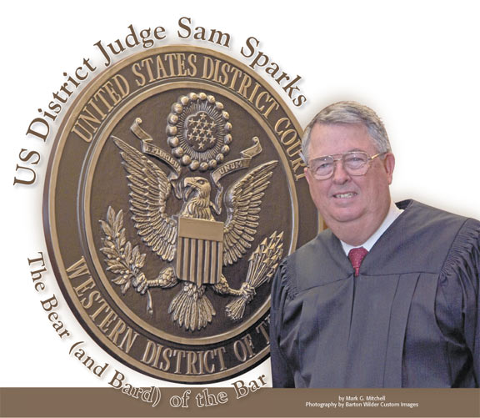  US Judge Sam Sparks  US District Court  Western District Texas  U.S. District Clerk's Office  655 East Durango Blvd., Room G65  San Antonio, Texas 78206  210) 472-6550  Chris Walters  vs  Kenneth Apfel  Commissioner of  Social Security  Judge Sam Sparks  Civil A:99CA0156SS | 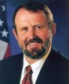  Social Security Commissioner  Kenneth Apfel  Before  United States District Court For  for the District of Columbia  333 Constitution Ave., N.W.  Washington, DC 20001  District of Columbia  202-354-3190  Chris Walters  Plaintiff Pro Se  vs  Kenneth Apfel  Commissioner of  Social Security  Judge Robertson  CA 99-CV-0668 | 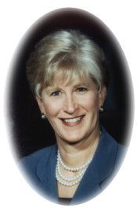  Secretary Carmen Odom Hooker  Before  Before the Superior Court  In Forsyth County  Hall of Justice  201 North Main Street  Winston Salem,NC  David Bradshaw  vs  Chris Walters  Carmen Odom  Case 04CVS2674

Your Request Is Prohibited By Federal Court ORDER
Katherine Garrett
Share Outreach Program Director
PO Box 1209
Share House
Vancouver, WA 98666
1 (360) 695-7658×304

RE: Appeal Case Management Ruling:
Request Prohibited ORDER Federal Judge;

Dear Outreach Program Director Katherine Garett:

I wanted to thank your case manager Lanni Kali for offering to develop a case management plan for employment, ssi, and long term housing. Unfortunately the Social Security Administration has secured a number of exotic ORDERS from several federal courts which places these matters in the hands of the Social Security Appeals Council… The Social Security Commissioner has been successful in pleading the exclusive right of the Appeals Council to determine if I am employable or disabled and her rights have thus far been sustained by rulings of Justice Scalia of the US Supeme Court. To avoid additional problems where nonprofit agencies and others are penalized or sanctioned the 5th US Circuit Court issued a final ruling that the matter is closed and cannot be reconsidered by any, group, or organization the matters being removed to Congress. You might say that until the Appeals Council issues it’s final report we are casual observers on the slow moving bus of government and some of the rulings relate directly to questions asked by Lannie Kali:
- The proposal for employment was provided to the Social Security Appeals Council in the Appellate document based on the findings of the Washington DSHS and social security medical representative Dr. Eric Strandberg in April, 2006 and is pending review..

- Lanni wanted too know if I would give up my employment opportunity with PublishAmerican to seek more gainful work which involves the US Supreme Court doctrine that all employment in the United States is “at will” and cannot be regulated by any government or process of law-Cite Walters v Askew USDC, SDNY (1976)

- Lanni wanted to know if I would be willing to step over the disability statement of Dr. Eric Strandberg and other doctors to seek work which the United States Supreme Court has ruled in Terry Schindler Schiavo V Michael Schiavo that the patient is the ultimate decider of what is or is not appropriate course of action regarding medical issues.

- The complex rules of federal laws provide that material issues of law before Courts is not subject to review by 3rd parties for instance US Department of HUD or nonprofit agencies and provides criminal penalities such under Title 18 USC 402 Contempt for persons overstepping or challenging the Courts authority.

- The US Department of HUD funds Share House and requires it program vendors to accommodate persons who are either disabled or unemployable-Cites Title 18 USC 371

With Kindest Regards Chris Walters

Mr. Chris Walters-Bed #22
C/o PO Box 1209
Vancouver, WA 98666
Wednesday, November 22nd, 2006

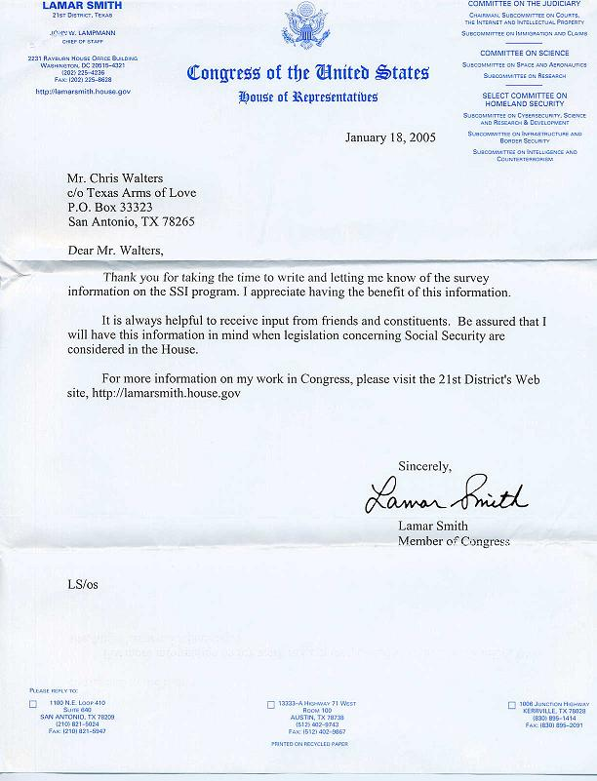  US Congressman Lamar Smith  Chairman House Committee On Judiciary  Guaranty Bank Building  1100 NE Loop 410  Suite 640  San Antonio, TX 78209  210-821-5024  210-821-5947 fax | 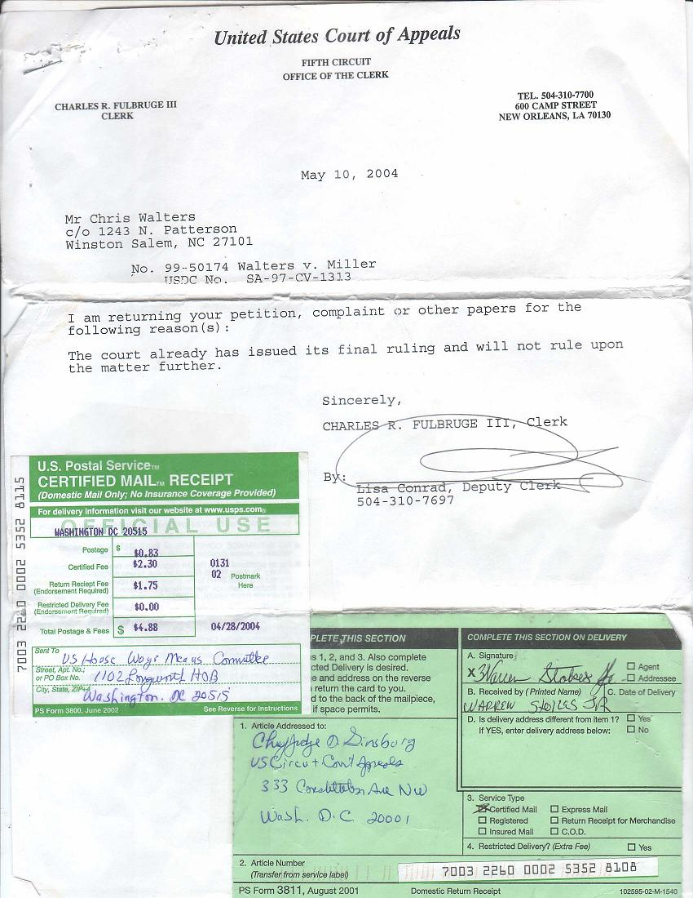  US Circuit Court of Appeals  For The Fifth Circuit  600 Camp Street  New Orleans, LA 70130  (504-310-7700

